R Markdown Output
Last run on: 2022-11-15 06:12:30

Overview
This document has code embedded throughout. In the next section we will create a visualization using the already loaded dataset eth_data:
datatable(eth_data)

Price Chart - Ethereum
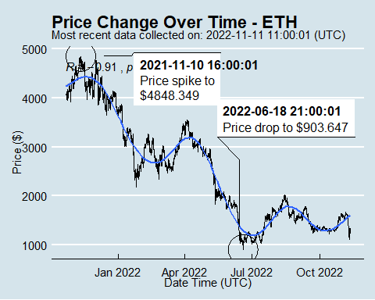

Python Code Example
removed for now because of package install automation issues

